

Reflecting on
Practical Work


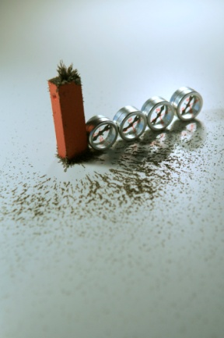

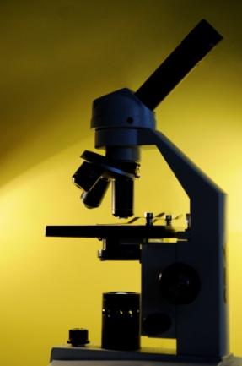

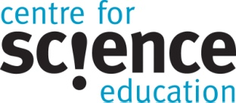

Getting Practical: Improving Practical Work in Science
Introduction
‘Science without practical is like swimming without water’ (SCORE, 2008)
The vast majority of science teachers will empathise with this comment. Practical work is an integral component of science teaching. However, defining the real value and purpose of practical work poses a difficult set of questions and divides opinion across the science education profession. We know that we want to do practical work, and we feel strongly that it must be part of science teaching, but we are not always sure why, what its benefits are or how to get the most from it.
The activities described in this book aim to address these issues. They help teachers to take stock of the practical work they do, by considering its key aims and objectives and evaluating its effectiveness.
This is not a compendium of new practical activities, nor a recommendation of equipment and techniques. Instead, the aim is to help teachers reflect on their use of practical work and to consider how small changes in its staging can make it more effective.
Three key sources were used to provide the background, content and structure for this project:
- Robin Millar's (University of York) research on the role of practical work in the teaching and learning of science
- A report, following a series of questionnaires and interviews with educators, published by the Science Community Representing Education (SCORE) in 2008 entitled Practical Work in Science: A report and proposal for a strategic framework
- A self-study pack produced by the National Strategies (Interactive Practicals), designed to help teachers review and improve their delivery of practical work
Full details of these sources are given in the Recommended Reading.
The activities described here underpin the first sessions of the Getting Practical Continuing Professional Development (CPD) package, which is delivered by the national network of Science Learning Centres. The later sessions in the CPD package look at how practical work is staged in the classroom, developing effective approaches to practical work and exploring resources.
What is Practical Work?
Most science lessons involve a range of teaching strategies, some of which come under the umbrella of practical work.
The nucleus of practical work relates to pupils’ interactions with objects, in order to observe and develop their understanding of the natural world. It encompasses laboratory procedures and techniques, investigations and fieldwork. Some teachers may feel that its definition goes further, to include activities such as analysis of secondary data, computer simulations, modelling and role-play, discussion generated from observations, or carrying out surveys (SCORE, 2008).
The following definitions of practical work underpin the activities described in this book:
‘Any science teaching and learning activity which at some point involves the students, working individually or in small groups, in observing or manipulating objects to develop understanding’
Millar (2009)
‘Any activity that enables pupils to have direct, often hands-on, experience of the phenomena they are studying’
The National Strategies (2008)
An interesting point to consider here is whether teacher demonstration falls within these definitions. However, whether it does or not, the principles of practical work apply to both pupil and teacher-led activity; the key issue is to make it effective.

What is the Purpose of Practical Work?
Practical work is often described as ‘hands-on’ activity but this is a limiting description. Its over-arching principle is to make links between the concrete and abstract worlds.
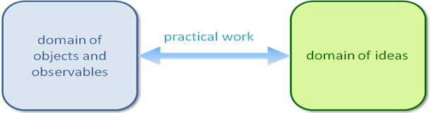
Tiberghien (2001) and Millar and Abrahams (2008) describe this as a link between two domains of knowledge: that of observables and that of ideas (Figure 1). Pupils therefore need to be engaged in the scientific ideas behind the practical work they are carrying out, whether these are about the concepts they are investigating or about approaches to enquiry.
Figure 1: Practical work enables pupils to make links between the domains of observables and ideas
This gives rise to a compelling mantra for practical work: hands-on, minds-on.

Case studies: Introduction
The case studies described here are the result of a series of workshops held with teachers as part of the development of the Getting Practical mapping activities. The teachers involved explored the key research which forms the foundation of Getting Practical and developed the content and use of the audit and reflective tools. They considered how best to use the tools and what their impacts might be on classroom practice.
Following the workshops, the teachers took the tools back into their schools to share with their colleagues and further develop their use. A few weeks after the final workshop, they were asked to report back on the impact of the audit and review tools on their practice, and these reports were developed into the following case studies
The case studies were drawn from a wide range of secondary teachers, from newly qualified to advanced skills teachers, who came from across the spectrum of secondary schools, including inner-city schools in challenging circumstances and high-achieving specialist science colleges. They describe a number of approaches to the use of the audit and review tools, and some interesting (and sometimes unexpected) outcomes.
For example, one teacher asked his pupils their opinions of the effectiveness of a particular practical, and found that they were able to identify that they had enjoyed the practical without learning anything from it! This led to a move away from doing practical work 'for the sake of it' and into more careful planning and staging so that pupils achieved 'minds-on' outcomes as well as 'hands-on'. Another teacher realised that he did not need to plan separate practical and theory lessons; by teaching the theory through the practical work, his pupils learned both more effectively and more efficiently.
Some teachers worked with their department to audit their use of practical work across schemes of work. This led to identification of gaps in their planning, and a chance to balance the learning achieved through practical work. Others worked with initial teacher trainees, who found that the review tools enhanced their reflections on their lessons and could be used to improve the staging of practical work for greater effectiveness.
All of the teachers involved found that their attitude towards practical work had changed, and that they developed a conception of it as a key learning strategy, not as add on activity.

Summary
The mapping activities described in this booklet are intentionally simple and straightforward. They do not need new equipment, activities or major changes to teaching methods and approaches. What they do require is for teachers to examine their pedagogy, their understanding of how they teach and how their pupils learn.
This may been seen as low priority or even an unnecessary burden (“I know how to do practical, thinking about it won’t make any difference”) but our observations of the activities in action has revealed enlightening moments for even the most experienced as the logic of the approach becomes clear.
I think it’s just clicked; I’ve been doing this for years and now understand why!
The use of the mapping activities is not recommended as a mechanistic approach to all lesson planning, but going through this process periodically is sufficient to create a positive change in approach and attitude.
There is concern throughout the science community that the status of practical work is in decline; this is the origin of the SCORE report. Many writers on this subject refer sensibly not to the quantity but to the quality of practical work (Wellington, 1998). It is this issue that the mapping activities in this booklet seek to address.
Practical work has always been an essential part of science teaching and will rightly remain so, but the teacher today has many other strategies in their armoury: ICT, argument and discussion, role play and simulation, high quality text, video, broadcast media and newspapers. All activities should stimulate, engage and motivate young people in their learning of science and practical work is no exception. It has to be planned with clear objectives and intended learning outcomes, and as an integral part of a well thought-out teaching sequence which will enable progression for all pupils.
The arguments about the importance of a good science education from both the individual’s and society’s perspectives are well rehearsed and documented. Ask anyone to relate a memory of their science education and they will undoubtedly recall an experiment (often going wrong!); ask a casual observer what they would expect to see in a science lesson and they will say experiments. As teachers we know that there is more to science education than this and we know that effective practical work is a central component of successful science teaching. The challenges set out here are to be clear in the purpose of practical work, to,choose practical activities which meet learning objectives, to stage activities to meet objectives, and to monitor and reflect on the outcomes of the practical experience.
We hope that in the activities outlined in this booklet will ‘turn on the light’ in a practical sense and help you to make the practical experiences of pupils purposeful, engaging and effective.

Recommended Reading
Millar, R. (2010) Analysing Practical Science Activities to Assess and Improve Their Effectiveness, Hatfield: Association for Science Education
The National Strategies (2008) Interactive Practicals Science Study Guide, Department for Children, Schools and Families. Available to download from http://nationalstrategies.standards.dcsf.gov.uk/node/284937 [version current at April 2010]
SCORE (Science Community Representing Education) (2008) Practical Work in Science: A report and proposal for a strategic framework, Gatsby Technical Education Projects. Available to download from http://www.score-education.org/2projects/practical_work.htm [version current at April 2010]

Other useful references
Abrahams, I. and Millar, R. (2008) Does Practical Work Really Work? A study of the effectiveness of practical work as a teaching and learning method in school science, International Journal of Science Education 30(14): 1945-1969
Millar, R. (2009) Analysing practical activities to assess and improve effectiveness: The Practical Activity Analysis Inventory (PAAI) York: Centre for Innovation and Research in Science Education, University of York. Available to download from http://www.york.ac.uk/depts/educ/research/ResearchPaperSeries/index.htm [version current at April 2010]
Tiberghien, A., Veillard, L., Le Marechal, J-F., Buty, C., Millar, R. (2001). An Analysis of Labwork Tasks Used in Science Teaching at Upper Secondary School and University Levels in Several European Countries, Science Education, 85 (5): 483-508
Wellington, J.J. (1998) Practical Work in School Science: Which Way Now?, Routledge: London

