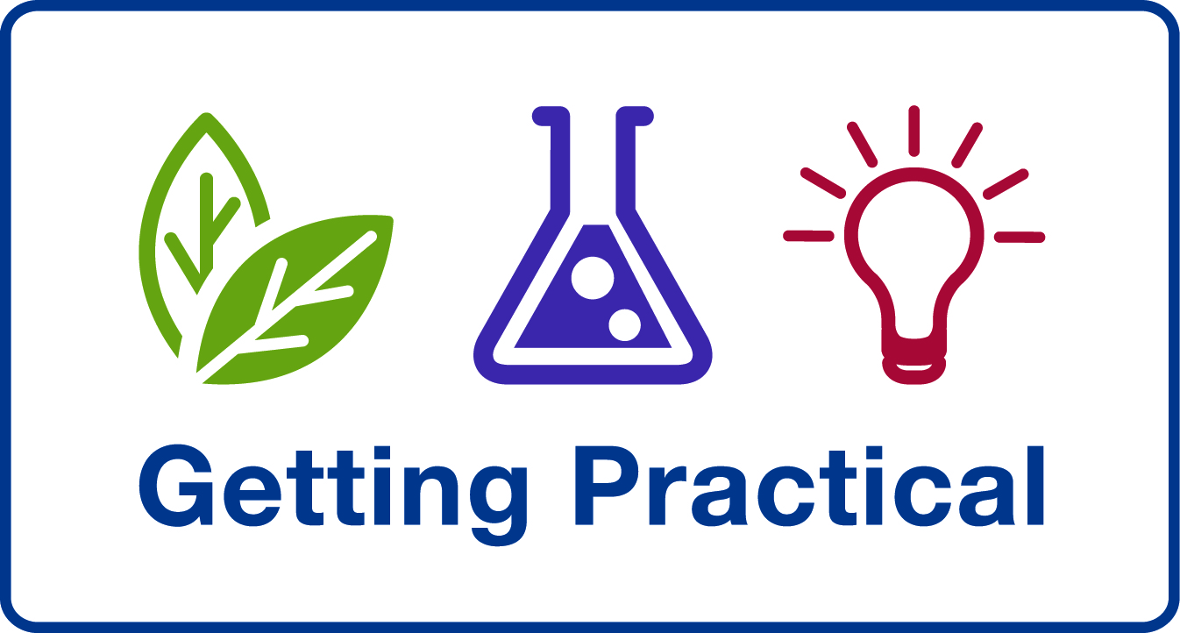
Effective Practical Science Seminar
ASE Annual Conference, Nottingham, UK
Wednesday 6th January 2010 2pm – 4:30pm

Getting Practical and SCORE along with the International Committee at the ASE are hosting a seminar on ‘Effective Practical Science’ with an international flavour. We invite you to share your interest and enthusiasm for practical science in education during an interesting and informative afternoon of discussion as part of the ASE Annual Conference.

The seminar will host guest speakers from Europe with a variety of experiences of practical science in education offering perspectives from the UK, around Europe and working in the Far East. Their talks will form the basis of further ‘round table’ discussions focusing on topics such as student attitudes to science across the world, handling assessment of practical work in schools and the contribution of practical science to developing ‘global citizens’ and scientists of the future. This is an excellent opportunity for science educators from all over the world to get together and discuss key practical science issues. Further information can be found on the Getting Practical website .

The seminar discussions will form the basis of a paper which will be made available to all delegates.

There is a full programme of activities for the International Day with the Effective Practical Science Seminar forming the focus for the day’s events. There will be an International Dinner for guests in the evening on the Nottingham University campus. The International Day is the first day of a 4 day conference running from 6th – 9th January 2010.

Please see the conference pages of the ASE website, www.ase.org.uk for further information about registration, accommodation and the social programme. There are reduced rates for ASE members and for those attending multiple days.

We look forward to welcoming you to the ‘Effective Practical Science Seminar’ and know that you will enjoy the rest of the conference and find it a stimulating experience.

ASE Annual Conference 2010, International Day

Effective Practical Science – 14:00 – 16:30
Supported by Getting Practical (Improving Practical Work in Science programme) and SCORE

“Science without practical is like swimming without water” (Teacher response to SCORE research questionnaire). This statement should strike a chord with every teacher of science in every country. We invite you to share your passion for practical science in education with us and contribute to an afternoon of enthusiastic discussion and lively debate.

It is widely recognised that practical work in science addresses:
1. Developing knowledge and understanding of science
2. Developing skills in apparatus use and standard procedures
3. Developing an understanding of scientific enquiry

How much importance do different countries place on these three areas, and with what success?

Following the viewpoints from our speakers, delegates are invited to participate in round table discussions including:
- assessment of practical work in science
- student attitudes to practical science, and
- the contribution of practical science to developing well informed ‘global citizens’ and scientists of the future.

The afternoon’s discussions will form the basis for a paper which will be made available to all delegates at this seminar.

Chair for the afternoon: Justin Dillon from King’s College London, UK

Speakers:
Mikkel Bohm from Danish Science Communication, Denmark
Mikkel is experienced in working with European countries to promote practical science education through EUSCEA (European Science Events Association).

Gren Ireson from Nottingham Trent University , UK
Over the last two years, Gren has worked with teachers and students in South Korea, taking UK best practice in practical work in science to a country that traditionally does not teach science this way.

Robin Millar from the University of York, UK
Robin Millar is Salters Professor of Science Education at the University of York. He has been involved in a number of research projects on aspects of practical work and has written extensively about its use as a teaching and learning strategy in school science, including a review of research on the effectiveness of practical work, for the forthcoming second edition of Good Practice in Science Teaching (Open University Press). He helped to develop the theoretical framework for the ‘mapping’ and CPD strands of the Improving Practical Work in Science programme.

