National CPD programme
Getting Practical: Improving Practical Work in Science
Course Trainer: Kath Twin LBBD
Maximum number of participants 20

Jo Richardson Community School, Castle Green, Gale Street, Dagenham, RM9 4UN 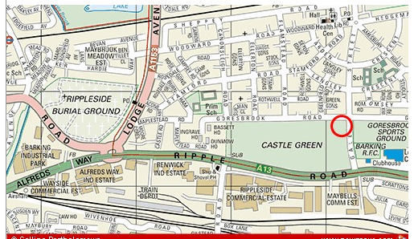

The course will be run over three twilight sessions
Date | Time and Venue | Session focus
May 10, 2010 | 16:00 – 18:00 JRCS | Reflecting on practical work
May 17, 2010 | 16:00 – 18:00 JRCS | Staging practical work
May 24, 2010 | 16:00 – 18:00 JRCS | Modelling practical activities
There is no charge for this national CPD. Tea and light refreshments will be available. Course participants will receive a national certificate on completion of the three sessions.
This national programme aims to improve the:
- clarity of learning outcomes associated with practical work
- effectiveness and impact of practical work on learning
- quality rather than quantity of practical work and to ensure that these developments are sustainable in schools

This course is aimed at science teachers, technicians, teaching assistants and SEN support in science and will include opportunities to discuss transition issues and links with science APP.

To register please complete and return the reply slip attached.

Reply Slip
Getting Practical: Improving Practical Work in Science
Jo Richardson Community School, Castle Green, Gale Street, Dagenham, RM9 4UN

Key learning objectives for the Getting Practical CPD:

- To consider why we do practical work in science
- To reflect on how we best develop learners’ understanding and skills through practical work
- To explore how we present and stage practical activities so that they effectively deliver particular learning objectives

Date | Time and Venue | Session focus
May 10, 2010 | 16:00 – 18:00 JRCS | Reflecting on practical work
May 17, 2010 | 16:00 – 18:00 JRCS | Staging practical work
May 24, 2010 | 16:00 – 18:00 JRCS | Modelling practical activities

Please return to: Kath Twin
Science Consultant
Westbury Centre
Ripple Road
Barking IG11 7PT

Telephone: 020 8270 4872
Fax: 020 8270 4811
E-mail kathy.twin@lbbd.gov.uk

PLEASE PRINT YOUR NAME AND DETAILS CLEARLY

Full Name _____________________________________________________
(to appear on certificate of attendance on completion of the 3 sessions)

School

e-mail __________________________________________________________________

