This course could transform the
effectiveness of your classroom practice
and help improve your learners’
experience of practical science. It will
show you how to plan, rehearse and
stage your practical activities to produce
learning outcomes with impact.

Getting Practical
Gives primary and secondary science teachers an opportunity to reflect upon how they use practical work and, if necessary, make small changes to improve the effectiveness of their teaching.

Getting Practical is focusing on improving the:
- Clarity of the learning outcomes associated with practical work
- Effectiveness and impact of the practical work
- Sustainability of this approach for ongoing improvements
- Quality rather than quantity of practical work used

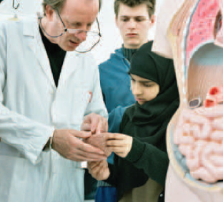
To reserve a place please complete and return the booking form to Lisa Stuchfield by 18th February or email lstuchfield@royalliberty.org.uk
Free CPD events

Option 1: One full day

28th February 2011 9am-3pm

Option 2: One full day

21st March 2011 9am – 3pm

Getting Practical CPD Event

At : The Royal Liberty School
Upper Brentwood Road, Gidea Park RM2 6HJ
Telephone: 01708 730141
Booking Form

Please reserve ________ place(s) on the Getting Practical CPD taking place on (delete as appropriate)

- Option 1 – 28th February 2011 9am-3pm
- Option 2 - 21st March 2011 from 9am – 3pm

Name of delegate(s) ______________________

School / institution _______________________

Address
________________________________________________________________________________________________________________________________
Telephone ___________________________
Email address _________________________
Lunch will be provided – please indicate any dietary requirements you may have.
________________________________
Please return the booking form by post to the above address, or email to lstuchfield@royalliberty.org.uk

