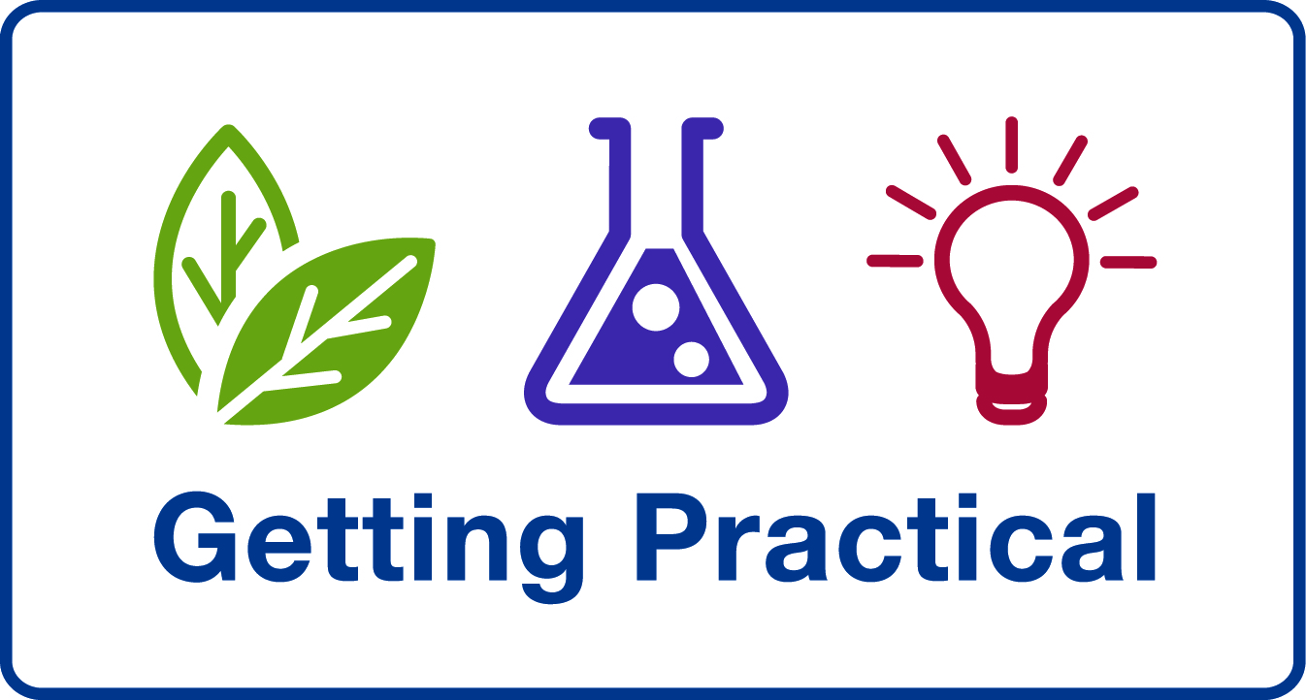
Primary

Are you ready to look at your teaching with fresh eyes?

Do you wish you could do something more with the tired science activities that clog your schemes of work?

Then ‘Getting Practical’ is the course for you!

Getting Practical is a reflective course, exploring the pedagogy behind practical science teaching, linking ‘hands-on’ with ‘minds-on’. It will enable you to get the most out of practical activities through:
- purposeful use of practical activities in an enquiry-based approach
- having clear learning outcomes for practical activities
- developing the quality rather than quantity of practical work
- providing tools to support you in embedding and sustaining these developments

Weds 26 May
9:00 – 3:45
Westbury Centre
Ripple Rd
Barking
IG11 7PT

Key learning objectives for the Getting Practical CPD:

- To consider why we do practical work in science
- To reflect on how we best develop learners’ understanding and skills through practical work
- To explore how we present and stage practical activities so that they effectively deliver particular learning objectives

Some key outcomes:

Teachers will be:
- More reflective about the quantity and effectiveness of their practical teaching
- Able to use the tools available through the CPD to confidently plan, carry out and assess the effectiveness of their practical activities.
- Talking with colleagues, sharing good practice and cascading the CPD materials via coaching, staff meetings etc.

Pupils will be:
- Aware of their own learning outcomes, and able to explain (when asked) why they are doing a particular practical activity and what they have learned from it.

To book a place contact: Liz Lawrence liz.lawrence@lbbd.gov.uk 020 8270 4867

This is a FREE course for Primary Teachers

