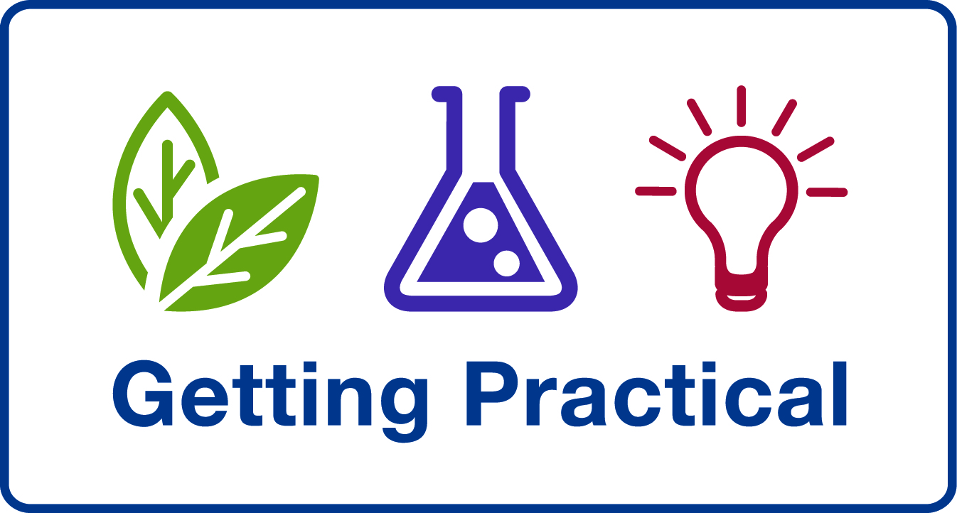
Primary NQT

Are you ready to reflect on your first year’s teaching of primary science?
Do you want some ways forward with developing your practice in primary science teaching?

Then ‘Getting Practical’ is the course for you!

Getting Practical is a reflective course, exploring the pedagogy behind practical science teaching, linking ‘hands-on’ with ‘minds-on’. It will enable you to get the most out of practical activities through:
- purposeful use of practical activities in an enquiry-based approach
- having clear learning outcomes for practical activities
- developing the quality rather than quantity of practical work
- providing tools to support you in embedding and sustaining these developments

Weds 25 May and Weds 29 June 2011
1:00 – 4:00
Ripple Primary School Westbury Site
Ripple Rd
Barking
IG11 7PT

Please note that you must attend both sessions

Key learning objectives for the Getting Practical CPD:

- To consider why we do practical work in science
- To reflect on how we best develop learners’ understanding and skills through practical work
- To explore how we present and stage practical activities so that they effectively deliver particular learning objectives

Some key outcomes:

Teachers will be:
- More reflective about the quantity and effectiveness of their practical teaching
- Able to use the tools available through the CPD to confidently plan, carry out and assess the effectiveness of their practical activities.

Pupils will be:
- Aware of their own learning outcomes, and able to explain (when asked) why they are doing a particular practical activity and what they have learned from it.

To book a place contact: Liz Lawrence liz.lawrence@lbbd.gov.uk 020 8270 4867

This is a FREE course for Primary NQTs

