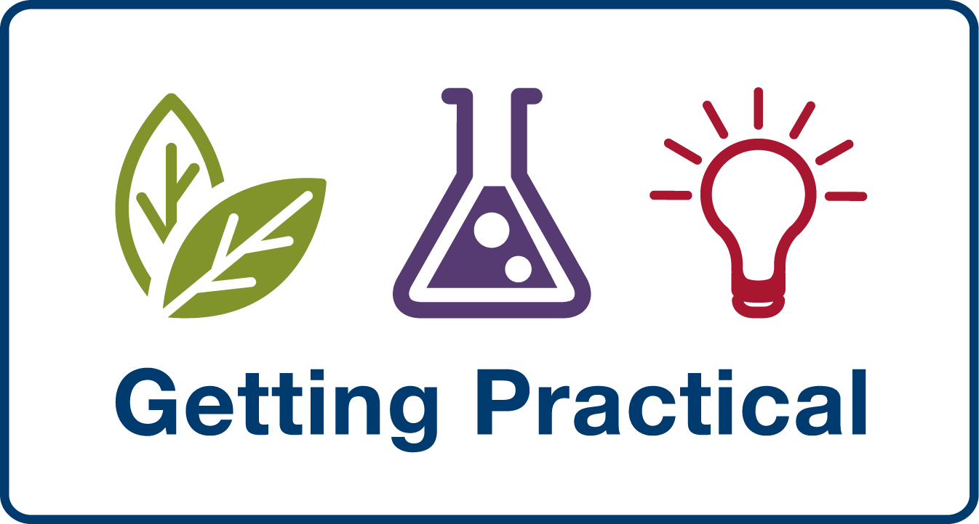

Exhibitors in the ‘Market place of Ideas’

ASE
Membership is open to everyone with an interest in science education.
Whether you are a professional teacher, technician or advisor, an organisation providing training or resources, a publisher or a manufacturer or supplier of equipment; or you just share our passion for science, you have much to gain by becoming a member of the Association for Science Education.
As the professional body for all those involved in science education from pre-school to higher education, and as the largest subject association in the UK, the ASE provides a national network supported by a dedicated staff team and a unique range of services to promote high quality science education and foster the professional development of the members. For more information, visit www.ase.org.uk.

ASE – Outdoor Science Working Group
Border Crossings: 8 innovative teaching resources incorporating best practice in terms of assessment for learning and cognitive acceleration which can be used by both mathematics and science teachers in ways which promote cross-curricular work. Border Crossings is designed to explore some of these new opportunities for science and mathematics teachers to cross their traditional subject borders. It builds on the success of earlier projects Let's Think Through Science (aimed at teachers of science at KS2), London Outdoor Science, Thinking Beyond the Urban Classroom and Trailblazers (a well-established and highly successful outdoor learning programme involving schools throughout Hampshire). Border Crossings is funded by the AstraZeneca Science Teaching Trust. For more information, please contact Prof. Justin Dillon, justin.dillon@kcl.ac.uk.

Brambleside Community Primary School
Practical lessons incorporating sporting activities and the use of technology to teach scientific enquiry (years 3/4/5/6). Work about Food Technology in Science lessons to highlight teaching important life skills can also enhance scientific understanding and enquiry skills (years 3/4/5/6). The display will be a mix of theoretical lesson planning ideas, photos and examples of children's work. For more information, contact Evelyn Clawson, evelync3@brambleside.northants.sch.uk

CLEAPSS,
CLEAPSS will be displaying a few examples of our resources to illustrate CLEAPSS’ commitment to and support for practical work in science and technology in schools and colleges. For more information, please visit www.cleapss.org.uk

Getting Practical
Getting Practical will support teachers, technicians and teaching assistants to improve the effectiveness of practical work through using, tailoring and managing practical science activities to meet whatever purpose the teacher has in mind.
Getting Practical aims to improve the:
•clarity of learning outcomes associated with practical work
•effectiveness and impact of practical work on learning
•quality rather than quantity of practical work and to ensure that these developments are sustainable in schools
Visit our stand to read articles about the programme and pick up resources for practical work in science. You will also be able to buy books covering the latest thinking in practical science education.
For more information, please visit www.gettingpractical.org.uk

Learning and Skills Improvement Service (LSIS) STEM Programme's
The LSIS STEM programme has recently developed 'Supporting Effective Practical Work', an online tool for continuing professional development (CPD). The tool is based on elements of the Getting Practical CPD programme as well as findings from 21 action research projects, supported by the LSIS STEM programme's 'Embedding Pedagogy into Practical Science' project. 'Supporting Effective Practical Work' has been informally evaluated by teachers and lecturers in Post 16 colleges. The tool is now available at http://tlp.excellencegateway.org.uk/tlp/stem/practical/. Delegates may also be interested in new resource, Managing STEM in the learning and skills sector available at http://tlp.excellencegateway.org.uk/tlp/stem/resources.html.

Royal Society

Royal Society of Chemistry
The Royal Society of Chemistry is the UK Professional Body for chemical scientists and an international Learned Society for advancing the chemical sciences. Supported by a network of over 46,000 members worldwide and an internationally acclaimed publishing business, our activities span education and training, conferences and science policy, and the promotion of the chemical sciences to the public. The RSC is the largest non-government supporter of chemistry education in the UK, supporting the teaching of chemistry within the primary, secondary and post-16 phases. We strive to modernise curricula and ensure new technology is appropriately used in science education.

We will be showcasing “Practical Chemistry LabSkills” - a set of engaging ICT resources designed to help students and teachers get the most out of practical chemistry lessons. It provides engaging and responsive practice opportunities to rehearse and prepare for real practical classes. LabSkills is not designed to replace practical work. The activities focus on getting the best out of time spent in the laboratory. Through TDA funding, a free copy of the basic package will be available to all UK state secondary schools. The RSC, ASE, Learning Science and the Getting Practical: Improving Practical Work in Science Programme have collaborated to provide this resource to enable all teachers to benefit from the resource. Visit the RSC stand to find out how you can get your free copy or visit www.discoverlabskills.org

Science and Plants for Schools (SAPS)
SAPS produces engaging, contemporary and reliable plant science practicals and resources for schools and colleges. Find out about our novel photosynthesis practical using ‘Algal Balls’, and sign up for free to become a SAPS Associate, where you’ll receive inspiration and practical ideas for use in the teaching of plant science. For more information, visit www-saps.plantsci.cam.ac.uk

Society of Biology
The Nuffield Curriculum Centre, in partnership with the Society of Biology, has developed a Practical Biology website for teachers of secondary school biology. The website allows teachers to download tried and tested biology experiments that should work in any school laboratory. The practicals can be used as starting-points for investigations and also for enhancement activities, such as clubs or open day events. To visit the website, go to: www.practicalbiology.org

Rachel Forsyth, Head of Education at the Society of Biology, will be showcasing the website and talking about how this project fits into the wider remit of the Society of Biology as the single unified voice for biology: advancing education and professional development; supporting our members, and engaging and encouraging public interest in the life sciences. To find out more about the Society of Biology visit our website www.societyofbiology.org

Tameside Transition Project
Judith Willis will be showcasing the project, particularly an activity called ‘Magical Liquid’

