This course could transform the
effectiveness of your classroom practice
and help improve your learners’
experience of practical science. It will
show you how to plan, rehearse and
stage your practical activities to produce
learning outcomes with impact.

Getting Practical
Gives primary and secondary science teachers an opportunity to reflect upon how they use practical work and, if necessary, make small changes to improve the effectiveness of their teaching.

Getting Practical is focusing on improving the:
- Clarity of the learning outcomes associated with practical work
- Effectiveness and impact of the practical work
- Sustainability of this approach for ongoing improvements
- Quality rather than quantity of practical work used

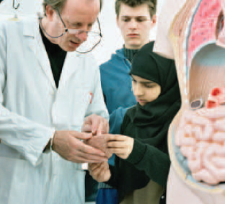
To reserve a place please complete and return the booking form to Karin Carroll by 14 January 2011
Free CPD events

Option 1: Two half days

9 February 2011 1-4pm
2 March 2011 1-4pm

This option includes a gap task which will allow you to practice and reflect on the changes in between sessions.

Option 2: One full day

2 February 2011 9am – 4pm

Getting Practical CPD Event

At : High Tunstall College of Science, Elwick Road, Hartlepool, TS26 0QL. Telephone 01429 261446

Booking Form

Please reserve ________ place(s) on the Getting Practical CPD taking place on (delete as appropriate)

- Option 1 - 9 February 2011 and 2 March 2011 from 1 – 4 pm
- Option 2 - 2 February 2011 from 9am – 4pm

Name of delegate(s) ______________________

School / institution _______________________

Address
________________________________________________________________________________________________________________________________
Telephone ___________________________
Email address _________________________
Lunch will be provided – please indicate any dietary requirements you may have.
________________________________
Please return the booking form by post to the above address, or email to kca@htcs.org.uk by 14 January 2011

