Background Reading to Albedo Investigation

What is Albedo
In astronomy, this means the stars we see are luminous but the planets are non-luminous so we only see planets when light is reflected from their surface. However, space is not dark there is a weak light from the stars. In this reflection the lighter, the colour of the surface the better it reflects light and in astronomy this is known as albedo. Albedo or Normal Albedo (from the Latin albus for "white") is defined as the fraction of light reflected by a body or surface or the percentage of electromagnetic radiation reflected by a surface; the ratio of electromagnetic radiation falling on the surface and that reflected from the surface:

Reflected radiation
Radiation hitting the surface

Albedo is used in astronomy to describe the reflective properties of planets, satellites, and asteroids and in climatology to determine changes in surface climates. It is affected by the nature and colour of the surface and its value ranges from 0, for a perfectly black surface, to 1, for a totally reflective surface; e.g. normal albedo for new snow, is nearly 1.0, and charcoal is about 0.04

Types of Albedo
Albedo is differentiated into two general types: normal, reflective or geometric albedo and bond albedo.

Normal albedo is a measure of a surface's relative brightness when illuminated by solar light and with the observations being made vertically above the surface of the planet.

Investigators frequently rely on observations of normal albedo to determine the surface compositions of satellites and asteroids. The albedo, diameter, and distance of such objects together determine their brightness. If, hypothetically, the asteroids Ceres and Vesta were observed at the same distance, Vesta would be the brighter of the two by roughly 10 percent, even though Vesta's diameter measures less than half that of Ceres, Vesta appears brighter because its albedo is about 0.35, whereas that of Ceres is only 0.09. Hence the material constituting the two asteroids must be different.

Bond albedo is named after US astronomer George P. Bond, who published a comparison of the brightness of the Sun, the Moon, and Jupiter in 1861, and it is defined as the fraction of the total incident solar radiation reflected by a planet back into space. Bond albedo is a measure of the planet's energy balance and dependent on the spectrum of the incident radiation defined over the entire range of wavelengths.

Earth-orbiting satellites can measure the Earth's bond albedo. Most recent value for Earth is approximately 0.33. The Moon, which has a very tenuous atmosphere and no clouds, has an albedo of 0.12. By contrast, that of Venus, covered by dense clouds, is 0.76.

Relationship between Normal and Bond Albedo
Astronomers have defined a simple relationship between the Bond albedo and the geometric albedo, which is called the phase integral. In many cases the Bond albedo and the geometric albedo have a ratio of 2 to 3, i.e. the Bond albedo is two-thirds the geometric albedo

Use of Albedo
Bond albedo is useful for determining the temperature of a planet in relation to distance because the calculated temperature is dependent on distance from the Sun and assumptions about planet's (moon's) surface reflectivity. If you look at a planet through a telescope, or just glance at the full moon it is apparent that the surface is not anything close to uniform and thus it's surface temperature would be expected to vary in a non-uniform manner.

This is related to Prévost’s theory (Swiss (1751 -1839) who, in 1791 proposed:

All bodies radiate heat, no matter how hot or cold they are; challenging the notion that cold was produced by the entry of cold into an object rather than by an outflow of heat. Therefore a body emits and absorbs radiant energy at equal rates when it is in equilibrium with its surroundings. Its temperature then remains constant. If the body is not at the same temperature as its surroundings there is a net flow of energy between the surroundings and the body because of unequal emission and absorption.
Using this idea it is possible to calculate the temperature of a planet. By making some assumptions about how a planet absorbs solar energy, one can calculate the planet’s temperature. In the simplest model, the planet is considered a blackbody. A blackbody is a perfect absorber; absorbing all radiation that falls on it. The blackbody will also emit all this energy as radiation making it a perfect radiator.

All matter at a temperature above absolute zero (-273.15ºC = 0K (kelvin)) radiates energy. The higher the temperature, the more energy is radiated.

For a blackbody, according to the Stefan-Boltzmann Law, the amount of energy emitted is proportional to the product of a constant—the Stefan-Boltzmann constant, σ, (value 5.67 x 10⁻⁸ Watts m⁻² K⁻⁴) and the fourth power of the body’s temperature, T⁴, (E = σ T⁴; where E = energy emitted, σ is Stefan’s constant and T is temperature in Kelvin)

This is because a planet is a spherical object and radiates over its whole surface so the total radiated energy would also be proportional to the surface area of the planet found by calculating, 4πR², resulting in the following equation (1):

σ T⁴4πR²

Astronomers assume that the planet radiates energy from the entire surface but only absorbs the energy on one face of the planet. Therefore the amount of solar energy that falls directly on to a spherical body like a planet would be equal to the cross-sectional area of the planet times the solar constant, S₀ so equation (2):

S₀ πR²

If we assume the planet is a black body and is in a state of equilibrium, neither heating nor cooling, the energy absorbed must be in equilibrium with the energy radiated or emitted. In mathematical terms, expression (1) must equal expression (2)

σ T⁴4πR² = S₀ πR²

This equation can be solved for the blackbody planet’s temperature, T₀, and is called its effective temperature. Astronomers define the effective temperature of a planet as:

The temperature that satisfies the energy balance of the planet when absorbed sunlight is equal to its emitted thermal energy

In examining this relationship the area of the planet is a required parameter. Now the area of a flat surface is π x r² but surface of a sphere is four times the flat surface area. If a planet is assumed to be an ideal ‘Black-Body’ and Stefan – Boltzmann’s law is used then the Moon, Mercury, Mars, Earth are close to "predicted" values, but Venus is much hotter, and the outer planets (the Jovian planets) only roughly approximate predicted values:

 | Actual Temperatures (ºK) |  |  | Calculated
Planet | Day | Night | Mean | Calculated
Mercury | 700 | 100 | 452 | 444
Venus | 721-731 | 732 | 730 | 323
Earth | 277-310 | 260-283 | 281 | 276
Moon | 380 | 100 | 280 | 276
Mars | 240 | 190 | 215 | 223
Jupiter | 120-150 | - | 120 | 121
Saturn | 120-160 | - | 88 | 90
Uranus | 50-110 | - | 59 | 63
Neptune | 50-110 | - | 48 | 50
Pluto | - | - | 37 | 44

To gain some idea of the way temperature changes across the Solar System the temperature needs to be plotted against distance from the Sun. In the following graph of temperature v distance, the distance is shown as AU where 1 Astronomical Unit (AU) is equal to the Earth's distance from the sun; 1AU = 149 598 000 kilometres.

However because energy is spread out over space, the planet temperature in Kelvin is on a logarithmic scale (a scale of measurement that uses the logarithm of a physical quantity instead of the quantity itself) and will vary linearly with distance from the sun. It illustrates the dependence of surface temperature on distance from the sun and albedo in the absence of an atmosphere (no greenhouse effect). For the Earth, an albedo of 0.29 corresponds to the "bond albedo"

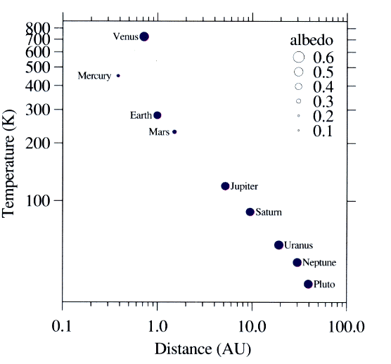
Graph from Leland Wilkinson’s The Grammar of Graphics (Springer 1999)

The exception on the graph is Venus, whose temperature is a consequence of the planet having a carbon dioxide atmosphere, and not the reflected energy; the albedo. If anything, its cloud layer lowers the temperature by reflecting the sunlight.

The graph appears to be not telling a coherent story in relation to the planets in the solar system so to rectify this we adjust the above graph to plot albedo against distance and not temperature. The values for clouds, and geographical features can be placed on the graph giving the following graph:

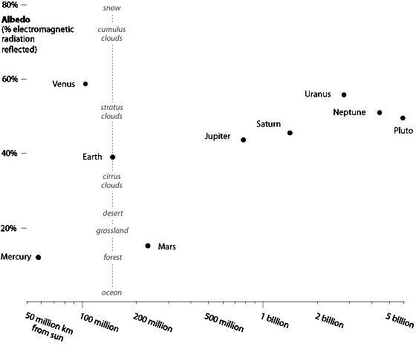

Albedo and Climatology
In climatology the concept of the albedo has a place and using the albedo of typical materials in visible light range from 90% for fresh snow, to about 4% for charcoal, one of the darkest substances, gives climatologists good information about climate changes. Deeply shadowed cavities can achieve an effective albedo approaching the zero of a blackbody.

Human activities have changed the albedo (via forest clearance and farming, for example) of various areas around the globe. However, quantification of this effect on the global scale is difficult. The classic example of albedo effect is the snow-temperature feedback. If a snow-covered area warms and snow melts, the albedo decreases, more sunlight is absorbed, and the temperature tends to increase. The converse is true: if snow forms, a cooling cycle happens. The intensity of the albedo effect depends on the size of the change in albedo and the amount of insulation; for this reason it can be potentially very large in the tropics.

Water reflects light very differently from typical terrestrial materials and water reflectivity is calculated using the Fresnel equations (see graph) for the reflectivity of smooth water at 20 C (refractive index=1.333).
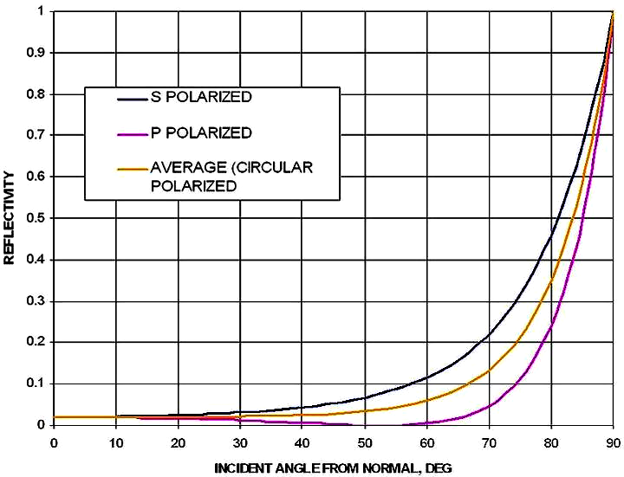

At the scale of the wavelength of light, even wavy water is always smooth so the light reflects. The glint of light off water is a commonplace effect of this. At small angles of incident the ‘waviness’ results in reduced reflectivity (from as high as 100%) because of the steepness of the reflectivity-vs.-incident-angle curve and a locally increased average incident angle.

Although the reflectivity of water is very low at high and medium angles of incident light, it increases tremendously at small angles of incident light such as that which occurs on the illuminated side of the Earth near the terminator (early morning, late afternoon and near the poles).

However, as mentioned above, waviness causes an appreciable reduction. Since the light reflected from water does not usually reach the viewer, so water is usually considered to have a very low albedo in spite of its high reflectivity at low angles of incident light.

The following chart summarises the relationship between the differing ideas in relation to albedo and infrared radiation.

