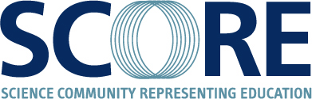
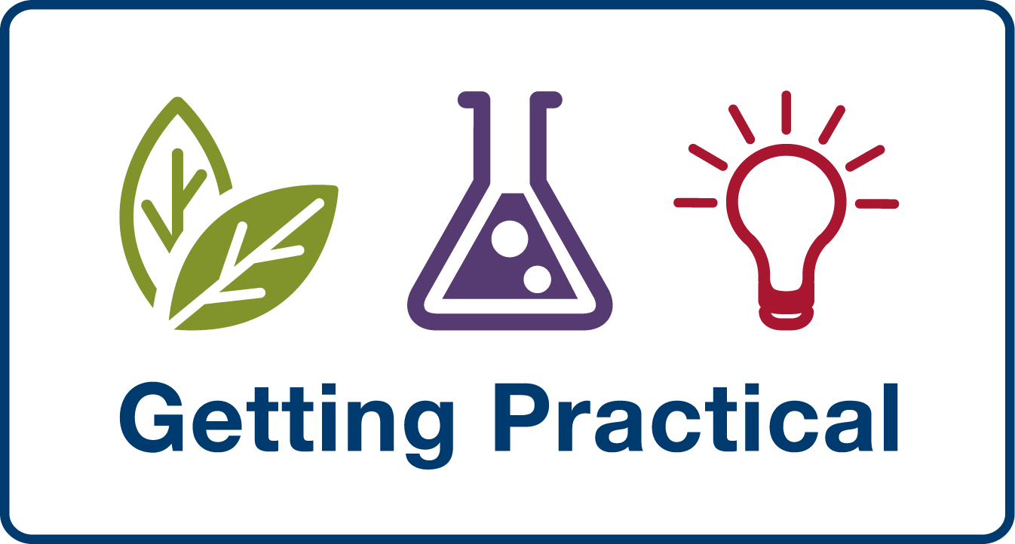

A Report on the Effective Practical Science Seminar held at the ASE Annual Conference, Nottingham, UK, January 6, 2010

By Justin Dillon, Professor of Science and Environmental Education, King’s College, London.

Getting Practical and SCORE, in collaboration with the ASE’s International Committee, hosted a seminar on ‘Effective Practical Science’ during the Annual Conference’s International Day, January 6, 2010. The seminar began with a series of three presentations and then the participants discussed a series of questions in small groups. The three speakers were Mikkel Bohm (Danish Science Communication), Gren Ireson (Nottingham Trent University) and Robin Millar (University of York).

Mikkel Bohm from the organisation Danish Science Communication spoke about three projects he has been involved in across Europe. He discussed how in Denmark, young people are being used in science communication roles to help them to understand topics more thoroughly and to promote science as an exciting and universal subject to the general public. The second project he spoke of involved school groups taking part in mass experiments across Scandinavia which produced some controversial results. Finally he introduced the audience to the organisation EUSCEA and its efforts to improve dialogue across Europe in science education through the 'Two Ways' project.

Gren Ireson, Professor of Science Education at Nottingham Trent University spoke of his experiences in 2008 and 2009 of running practical science workshops or 'Science Camps' in South Korea. There are many changes taking place in the way that government in South Korea view science education and now there is a greater emphasis on adding creativity to science and making practical work a higher priority in the classroom. Gren demonstrated some of the simple activities and experiments that he and his team took to South Korea.

Professor Robin Millar from the University of York talked about his research into practical science and discussed his 'minds on as well as hands on' philosophy. He outlined the key tools that underpin the Getting Practical programme and aid teachers in analysing the use of practical activities systematically to make its use in the classroom more effective.

The discussions started from the premise that, when carefully planned and taught, practical work in school science addresses:

1. Developing knowledge and understanding of science
2. Developing skills in apparatus use and standard procedures
3. Developing an understanding of scientific enquiry

The participants were asked to discuss their responses to the following questions:

- How do attitudes to practical science vary across Europe?
- How do young people view practical work?
- What challenges arise in cultures that do not traditionally embrace practical science?
- How can we support these cultures in providing for and teaching practical science?
- How can we as an International science education community support teachers in enabling more effective practical science?

Each group kept a written record of their responses and these were typed up and summarised. Each question is addressed in turn in the following sections.

How do attitudes to practical science vary across Europe?

Not surprisingly, delegates identified a wide range of attitudes and practices across Europe and the rest of the world. The aims and purposes of practical work vary both within countries and between countries and what goes on in the classroom and the laboratory may well be closely linked to what is assessed locally or nationally. As a result, teachers may choose practical activities that give reliable results rather than more open-ended investigations. At worst, ‘doing a practical’ can be no more creative than following recipes in cooking.

Teachers’ practices
As well as being constrained by the assessment system, teachers’ practices may be influenced by how they were themselves taught at school and by concerns for students’ behaviour. The teachers’ attitudes, knowledge and confidence can have an impact on students’ attitudes towards the sciences. Some participants thought that many teachers “go through the motions” when it comes to practical work and that too much time is taken up with getting things to work. This is one reason why teacher demonstrations are preferred, particularly in Asia and the Pacific regions where resources and technical support are often lacking.

One group noted that the role of the technician in the Netherlands is seen to be more proactive than it is in the UK which has an impact on the nature of practical activities carried out in Dutch schools.

Some examples of practices in participants’ countries emerged. In Germany, where practical work is not assessed in terminal examinations, teachers tend to carry out demonstrations rather than let children carry out the activities themselves. In Brazil, too, little practical work takes place. An important question for Brazilian students and their teachers is ‘Does practical work form part of university entry?’ As the answer is usually ‘no’, teachers do not see a need to use practical activities. Some schools in Norway use the IGCSE which involves a major practical assessment that requires significant preparation. One problem with that approach is that practical work might be seen as a test rather than as an opportunity to learn.

Curriculum content change
Changes to the science curriculum were reported by several participants. In Canada there is a move to influence the young people’s attitudes towards practical science through a focus on ‘day to day’ science. In South Korea, a new curriculum is introducing open enquiry and individual investigation for one semester. In Israel practical work is coming back through inquiry-based learning although science teachers are not always comfortable with this approach. Similarly, in Hong Kong, science teaching is moving from the use of closed questions to more open ended investigative questions.

It was suggested that in the Netherlands the curriculum supports the development of particular skills whereas in the UK and Norway, the curriculum suggests practical work is an important part of learning scientific concepts.

In the Czech Republic schools design their own curriculum so what is taught depends on the teachers and the head teacher and on how many hours are dedicated to science. This is a very ‘head’ driven system so the amount of practical science might be quite limited.

The aims and purpose of practical work
There is a difference between being a scientist and learning scientific ideas. Learning about how science works and learning science may require different activities. Students are often confused about the purpose of practical activities and the extent to which they relate to careers in science. Robin Millar and Ian Abraham’s work on the aims and purposes of practical activities raise issues about how teachers are trained to teach science and how practical activities are assessed. A question to be asked is ‘To what extent should science educators have a science research or theoretical background?’

Barriers to practical work
Although the UK is seen as a leader in terms of science education, it is still possible to identify barriers that inhibit teachers’ use of practical activity including class size and a lack of one or more of the following factors: finance, resources, qualified and skilled teachers, management support and time. Many of these factors apply to countries outside the UK.

One group noted that “boys dominate in practical classes” and suggested that “No mixed groups should be used for practical work”. Another group reported that in Spain classes are split into two making the learning more personalised and the demands on the teacher more manageable.

In terms of inter-country comparisons, it was noted that the practical work assessments in Norway are set by teachers but moderated by teachers from other schools. Participants felt that the assessment of practical work is less of an issue in the Netherlands or Norway compared to the UK.

How do young people view practical work?

Participants recognised that students’ attitudes towards practical activities varied. Some students “love it. It breaks up the day” and they value the fact that it is hands-on. Other students “see practical work as a way of relaxing, considering it as ‘down time’ and time to chat to their mates”. At worst, students think practical work is a “necessary evil that follows learning the theory”. It was felt that some students are “not keen on evaluation or interpretation of results or cleaning up!”

Student attitudes to science can be influenced by different factors. It was noted that a students’ home background might affect their career aspirations and it was reported that in South Korea, as in Italy, although practical work is seen as important by teachers, some parents do not want their children to do any. TV programmes can influence children’s attitudes to science and to practical work, with examples being given of the use of TV clips in classrooms in Canada and the UK.

Participants noted that as technology has developed, it has become harder to repair things that have stopped working. As a result, students’ knowledge of how things work has decreased in recent years: “in today’s world, you can’t fix things that have broken”.

One participant noted an interesting difference between UK and US students attending their international school. While the US students were content orientated and enjoyed book-work, they were more hesitant about practical work and then behaved inappropriately. The UK students, on the other hand, were more independent in their laboratory work.

What challenges arise in cultures that do not traditionally embrace practical science?

A range of challenges emerged from the discussions including the length and nature of pre- and in-service teacher training, the availability of technical support and the influence of textbook and curriculum content. In order to use practical work effectively, teachers need to “take a few risks with trying new things” and ignore the myths about health and safety restrictions on particular experiments. In some countries, teachers might see themselves as scientists first and teachers second or as biologists or chemists or physicists rather than scientists. Often it is the attitude that teachers have towards science and learning rather than their length of service.

It was noted that students are aware of advances in technologies and their applications. As a result, school science needs to show the role of science in everyday technology such as phones and computers.

Other dimensions of cultural differences include the degree to which students feel comfortable in challenging what the teacher says or does and one group wondered whether there “could be cultural resistance to practical work due to religious differences?”.

How can we support these cultures in providing for and teaching practical science?

Participants identified several ways in which cultures that do not traditionally embrace practical work could be supported. One suggestion was that there should be a global approach to CPD with “joined-up thinking on the matter”. It was noted that CPD should be used to raise awareness and increase confidence and that teachers should be trained to consider why the practical is being done and how it is followed-up.

One group suggested that “We should share resources across different countries and have more exchange visits”. The positive impact of the ASE’s Science Across the World project was noted. Inevitably, participants argued that the challenges could not be addressed without more teacher-training, more technical support and more financial support.

Some participants suggested that there might be a role for higher education student ambassadors in doing or promoting practical work in schools.

How can we as an International science education community support teachers in enabling more effective practical science?

Some participants noted the increasing use of the Internet and suggested a “more virtual” approach to science education and increasing student involvement in “international learning and partnerships” possibly through the use of sites such as YouTube. Other participants noted that it may be more effective to focus on low cost materials as money is the major issue in determining teachers’ choice of activities.

Issues for further study
A range of issues emerged from the discussions that might benefit from further study including how can we get more practical work into primary and early years teaching? Another issue was how does the International Baccalaureate compare with other courses in terms of the amount and quality of practical work?

