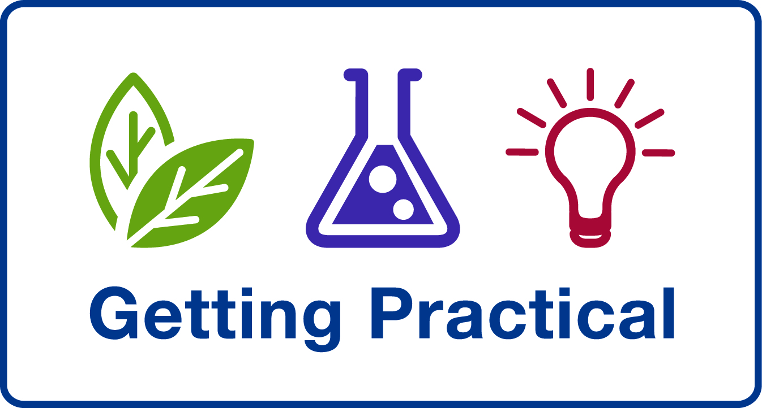
ASE Annual Conference 2010, International Day

Effective Practical Science – 14:00 – 16:30
Supported by Getting Practical (Improving Practical Work in Science programme) and SCORE

“Science without practical is like swimming without water” (Teacher response to SCORE research questionnaire). This statement should strike a chord with every teacher of science in every country. We invite you to share your passion for practical science in education with us and contribute to an afternoon of enthusiastic discussion and lively debate.

It is widely recognised that practical work in science addresses:
1. Developing knowledge and understanding of science
2. Developing skills in apparatus use and standard procedures
3. Developing an understanding of scientific enquiry

How much importance do different countries place on these three areas, and with what success?

Following the viewpoints from our speakers, delegates are invited to participate in round table discussions including:
- assessment of practical work in science
- student attitudes to practical science, and
- the contribution of practical science to developing well informed ‘global citizens’ and scientists of the future.

The afternoon’s discussions will form the basis for a paper which will be made available to all delegates at this seminar.

Chair for the afternoon: Justin Dillon from King’s College London, UK

Speakers:
Mikkel Bohm from Danish Science Communication, Denmark
Mikkel is experienced in working with European countries to promote practical science education through EUSCEA (European Science Events Association).

Gren Ireson from Nottingham Trent University , UK
Over the last two years, Gren has worked with teachers and students in South Korea, taking UK best practice in practical work in science to a country that traditionally does not teach science this way.

Thomas Visby from Vester Skerninge Friskole, Denmark
Thomas will be discussing how the United Nations Climate Change Conference, COP 15, has influenced science education policy in Denmark and how this is implemented in the classroom.

Robin Millar from the University of York, UK
Robin Millar is Salters Professor of Science Education at the University of York. He has been involved in a number of research projects on aspects of practical work and has written extensively about its use as a teaching and learning strategy in school science, including a review of research on the effectiveness of practical work, for the forthcoming second edition of Good Practice in Science Teaching (Open University Press). He helped to develop the theoretical framework for the ‘mapping’ and CPD strands of the Improving Practical Work in Science programme.

